Emergent Gaming Tech project!

Saw type idea;

- Lots of different rooms with random obstacles

- Time limit (If you runout of time you are locked in that room forever i.e. lose condition)

- Complete a specific number of rooms to finish the game which depends on difficulty.

- Multiple levels of difficulty; the harder the mode the more rooms you have to complete and the harder obstacles are.

Technology;

- Procedurally generated map.

- Random instantiation for room content

- HTC VIVE (For looking around)

- Either myo armband / HTC VIVE hand controllers for movement.

- Voice Commands. (Used for voice command specific challenges)

**Procedurally generated map.**

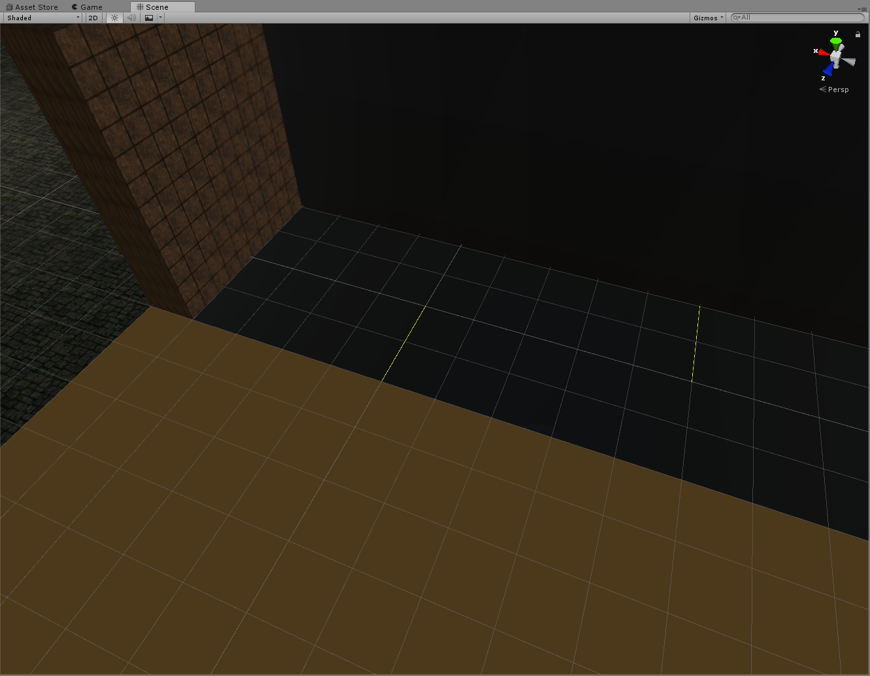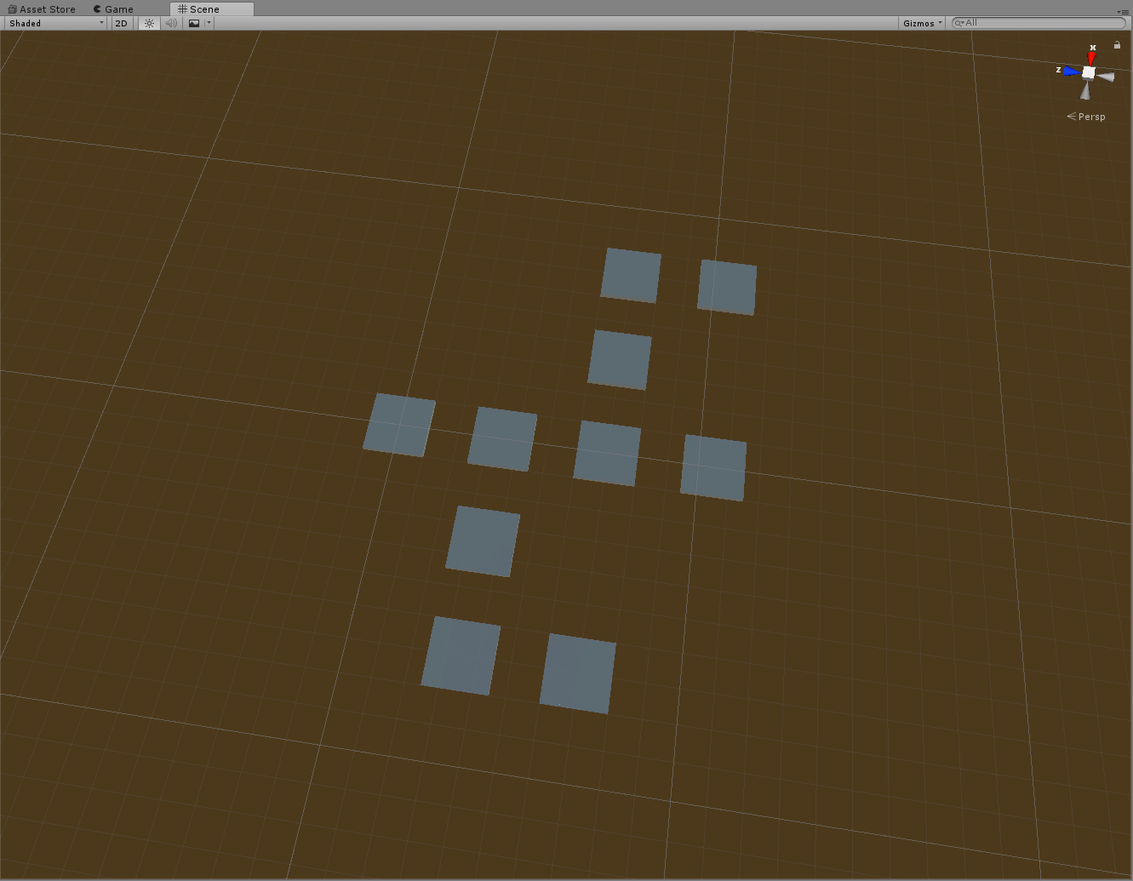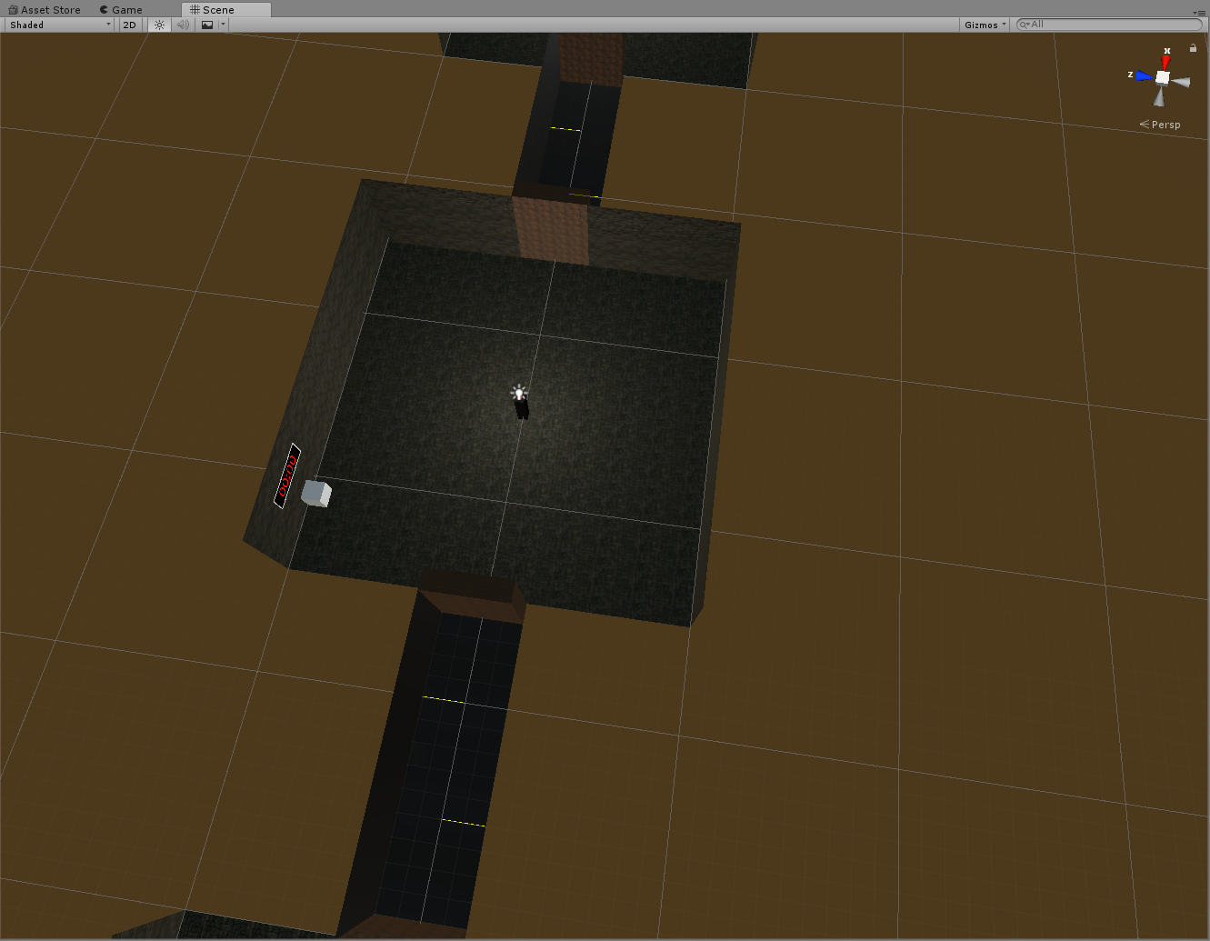  
We wanted to make a procedural play area for our game consisting of rooms.  
To do this, we first needed a way of creating the map to reserve locations within the game, so we first researched generating a grid-based array to store the locations of the rooms. We found a method which creates an array on runtime and instantiates a 2d sprite in its location. We adapted this script to use for our 3d assets. We did this by using gameobjects and instantiating game objects instead of sprites and changing the changing the position of the spawn location to work in a 3d space.  
  
Because our game has rooms connected by corridors we needed to find a way of connecting the rooms when they are generated at the start of the game. This can be achieved by having separate game objects in the code that can be spawned in depending on adjacent rooms or by procedurally creating the corridors when they are instantiated.  
We decided to have one standardized room that has all corridors built into it and spawn them in every location with a room. the corridors have a raycast on each corridor to detect adjacent rooms, if there isn’t a room there then the corridor is deleted a possible better way of doing this is to instead instantiating the corridors instead of deleting them, however it could take more processing to spawn in the corridors if the room has a lot of entrances. Spawning one object and deleting three corridors being better than spawning in five objects, the room and 4 corridors.